SERVICE FEE AGREEMENT BETWEEN EMPLOYER AND SERVICE PROVIDER
(Exhibit B)

SERVICE FEE AGREEMENT

[Insert Legal Name of Broker or Consultant] (“Service Provider”) and Wisconsin Manufacturers & Commerce (“Clients”) (collectively, the “Parties”) enter into this agreement on [Insert Date].

In consideration of good and valuable consideration, receipt and sufficiency of which is hereby acknowledged, the Parties agree to the following:

- Service Provider shall provide the services described in the attached Schedule A to this Agreement (the “Services”).

- Clients shall pay Service Provider a fee for such Services as is set forth in Schedule B to this Agreement (the “Fee”).

- Service Provider agrees to maintain any and all licenses required by any applicable state, local and/or federal regulatory agencies, and meet any and all legal requirements necessary to perform the Services and to receive the Fee.

- Both Clients and Service Provider understand and agree that entering into this Service Fee Agreement and the payment of the Fee is not a condition of the purchase or retention of any health insurance coverage, and that the Fee is not now, and shall never be, included as a component of any medical premium associated with a policy of health insurance which may have been or be in the future purchased by Clients, even if such Fee is administered by the insurance company issuing such policy and/or included on the same invoice with the medical premium for such insurance.

- Both Clients and Service Provider understand and agree that this Agreement shall continue in full force and effect until the earlier of: (a) the date the Service Provider is no longer legally authorized to perform the Services described herein (e.g. no longer maintains appropriate license); or (b) thirty (30) days from the date either Party provides the other Party with written notice of termination.

- Any provision of this Agreement may be amended or waived if such amendment is in writing and signed by each of the Parties.

_________________________________________ _______________
Employer Member Client Signature Date

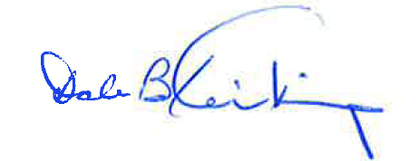 11/3/2020
Association Health Plan Client Signature Date

_________________________________________ _______________
Service Provider Signature Date

SERVICE FEE AGREEMENT SCHEDULE A

Provision of group health insurance.

SERVICE FEE AGREEMENT SCHEDULE B

ADDENDUM 1
MANAGEMENT FEE

The Association establishes the Management Fee to be paid by all Employer Members as the following:

Please check only one of the following Management Fee payment methods:

X Percentage of Required Contribution 1.5 %

[_] Per Employee Per Month (PEPM) $ [_____________] .00

